Week 8 – More racing

Last week’s race was fun but we only had one driver . Let’s make a race with two players and a computer driver. The ball is a little changed from last time to check that it is crossing the finish line in the right direction.

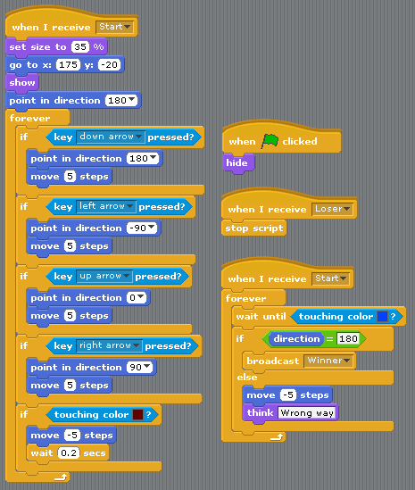

Second player

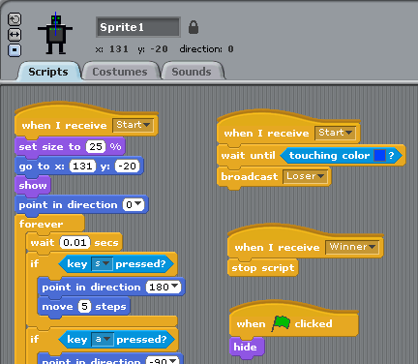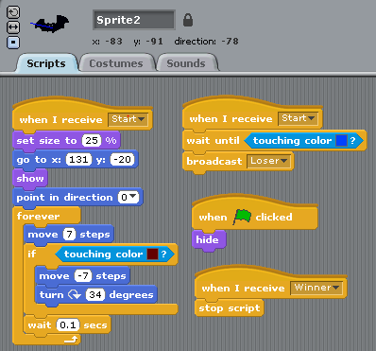Now let’s add a second player and an automatic maze runner. You can copy and modify the ball. You may need to play around with these to get them to run the maze automatically.

**Extras**

1. Make the race run for 3 laps
2. Keep score of laps by player